1. **Using Components:**
   * We created all these components, let's start using them. I will start using them in the app component HTML file here where I say I'm working.

**Recipes/Shopping List Component:**

* + Here I want to display my app recipes and shopping list component.

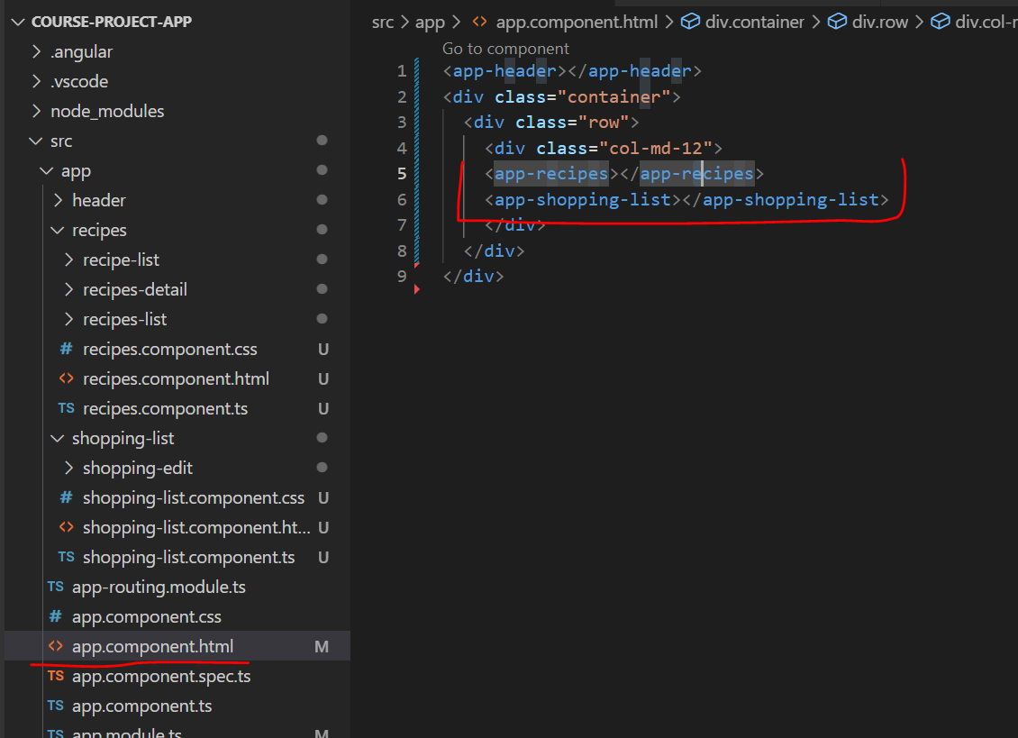

* + We can see the same in the browser also.

**Recipes:**

* + Now lets start working on the individual components, starting with recipes
  + I want to have the recipes list and detail next to each other.
  + So for this, I'll add a row div here and class: ***col-md-5***, to have a smaller column on the left, and then another div with ***col-md-7.*** These are bootstrap column sizing classes to have a broader column on the right. So two columns next to each other.
  + In the first column, I want to have my app recipe list component and in the second one. I want to have my app recipe detail component
  + So now we have two components next to each other.
  + If we save this and have a look at our app. We indeed see list and detail below each other simply because due to the console, the view port was so small and then it automatically wraps them below each other.
  + So if you have normal page, they sit next to each other and I actually want them to wrap
  + below each other on smaller pages.
  + So this is now working too.

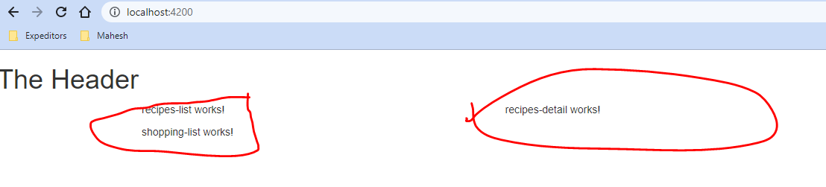

**Recipe-list-item:**

* + Now in my recipe list component here, as I said I somehow want to include that recipe item. So here(recipe-list.component.html) , I will later output a list of items. For now, I will simply include the App recipe item.

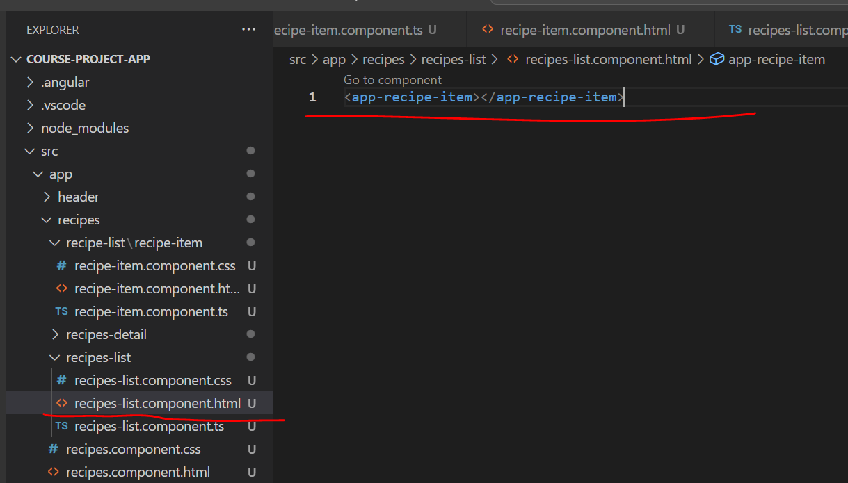

* + We can see the browser reflecting the same:

**Shopping list component:**

* + Now for the shopping list, I'll do pretty much the same in my shopping list component here. I want to display the list and above it is shopping edit area.
  + So I'll add a row here too. And in this row, let's say with class=”**col-xs-10**” to create a very wide column here, I'll first add my shopping added component to have this editing area at the top where we can add new ingredients or added existing ones.
  + And then I want to have a horizontal line here and somehow I'll output my list below this.
  + 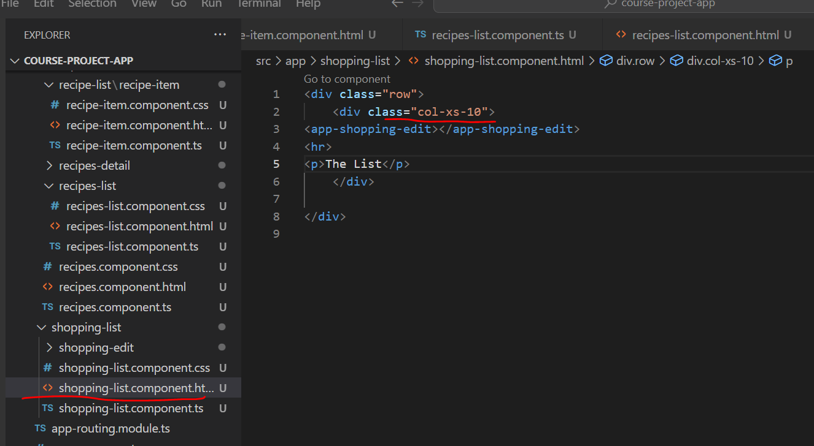

So it should work like this.

